Understanding Culture Society Politics

Millano, Rei Benedict L. 12-Laplace 8-22-2022

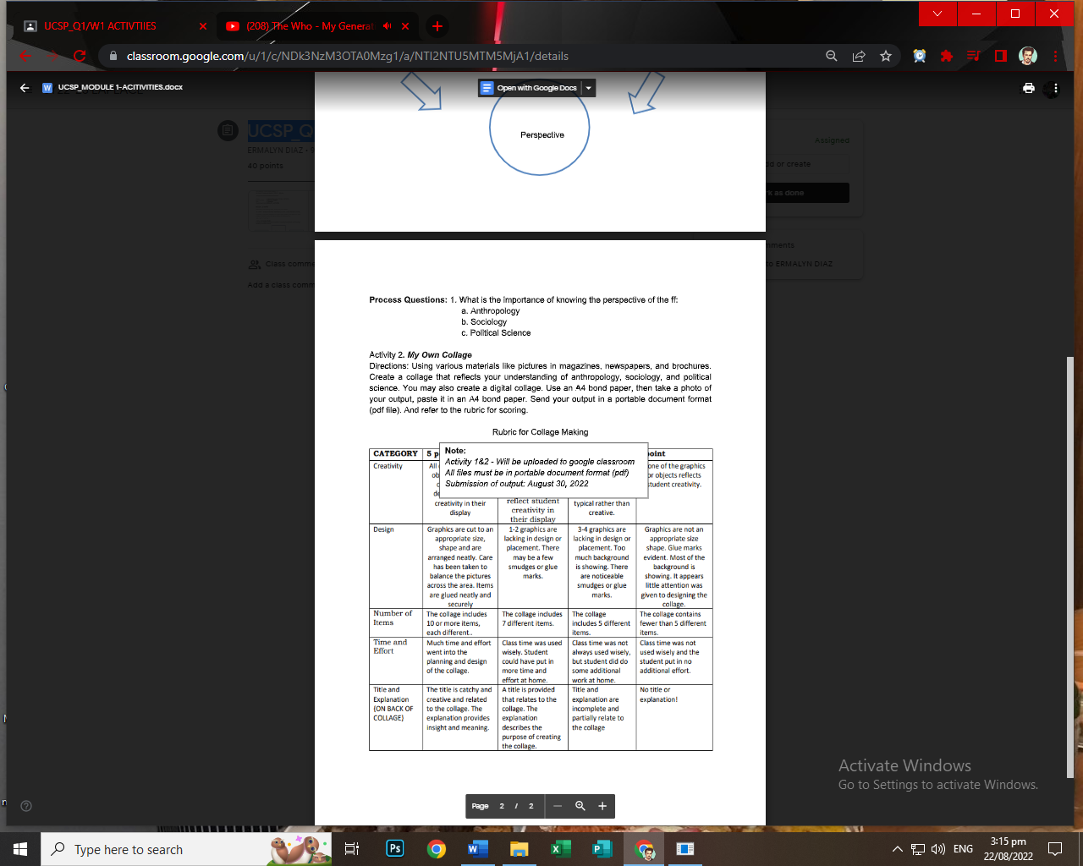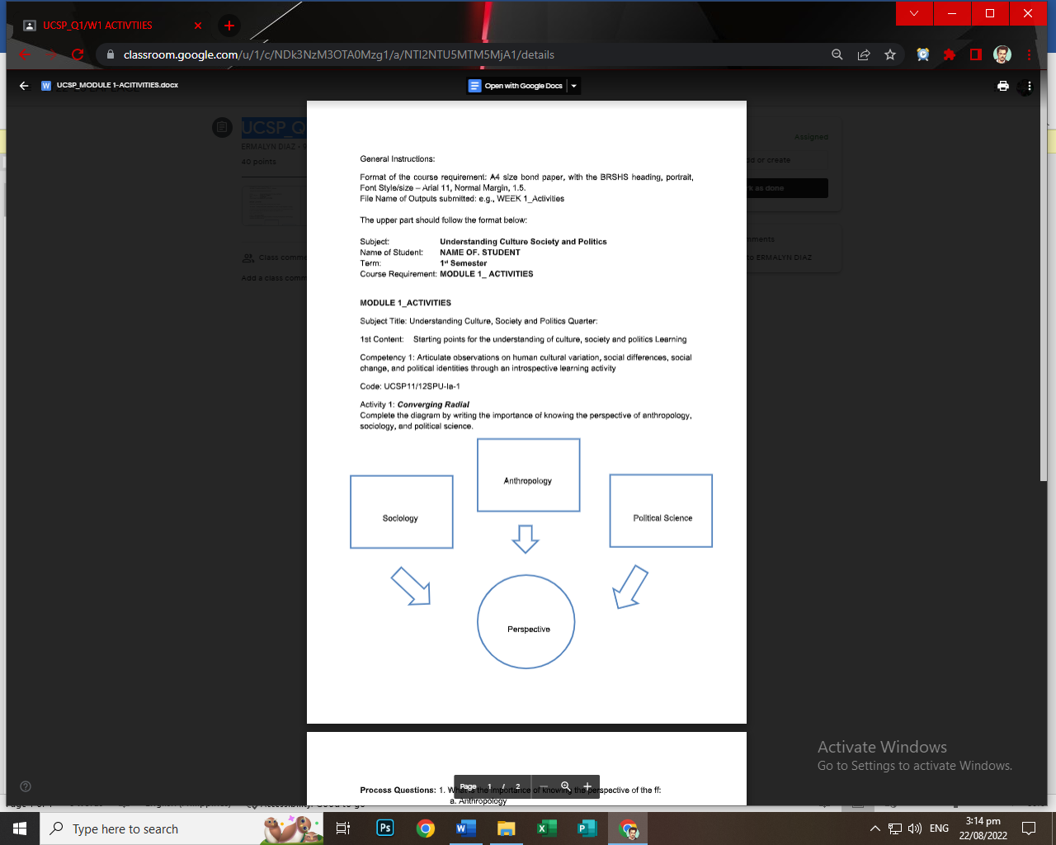

It is a type of social science that aims to understands mainly relationships or social interactions between people and the systems that people build such as hierarchies, power dynamics. As it concerns me as an individual in having a better perception on how society works

Peace and prosperity is the product of law and order maintaining the balance of each and everyone’s right to act. Where morality maybe subjective and relative, laws and regulations are discrete and abided by everyone no matter the status. Learning the ins and out of how politics influence power and actions of the people is necessary

The big focus of anthropology is answering what makes us human. The study can cover many subjects that relates to our history, culture, language, knowledge, heritage, biology and others as well. While broad it approaches each in scientific manner. Knowledge from the past gives us the wisdom to lead a better future

Process Questions:

1. Anthropology in comparison to sociology and political science shares main ideas surrounding humans. But it differs as anthropology covers a larger field and does go in too finer detail. As it uncovers past prior to present wisdom and seeks on how many societies and histories are formed.
2. Sociology studies modern, past and future predictions in how civilizations and society function. From the Macroscopic level of how institutions work and form to benefit and serve society. As it also aims to understands social trends and decision and how they were caused and affect the overall social order.
3. Political science can be said as the most practical or important because it is regularly used in creating systems, decisions that are used to govern and maintain citizens of countries, people of the state, and specific groups. As it concerns many people as a whole on how power such as collective interest and money to be used best in the interest of the group and its people.